Name: __________________________________
6th Grade Integrated Science
Course Description 2019-2020
Our Course
Welcome to Science with Ms. Moore! This year we will dive into multiple areas of science including:
- Unit 1- Physics and Chemistry
- Unit 2- Astronomy
- Unit 3- Biology
- Unit 4- Geology

Throughout the course students will interact with information through laboratory experiments, demonstrations and models. We will gather and use evidence from these activities to support complex scientific claims.

Grading Policy
Grades for the course will be determined by the following averages:
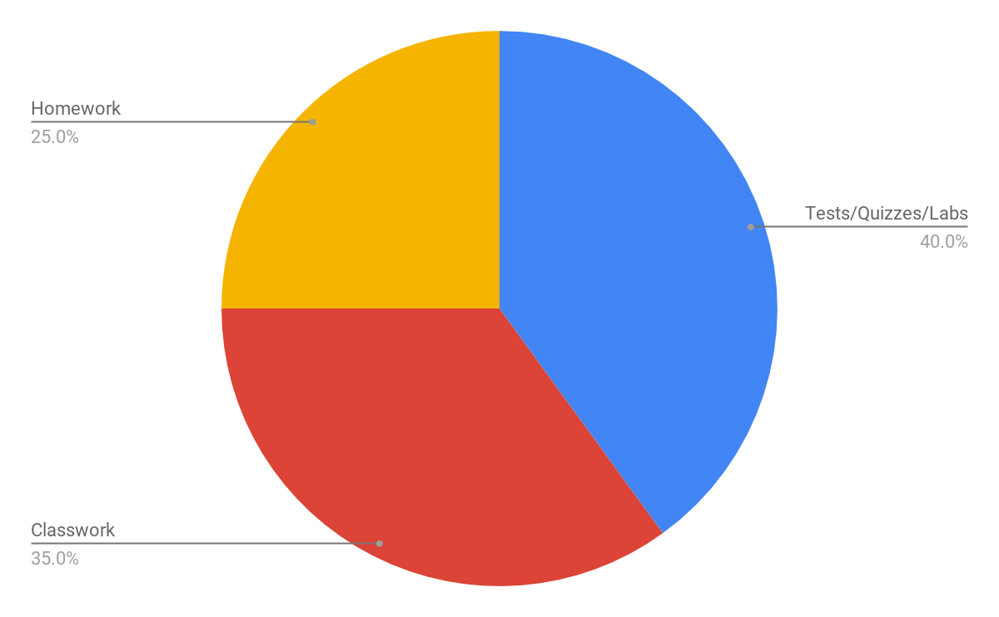
Tests/Quizzes/Labs | 40%
Homework | 25%
Classwork | 35%

Science Notebooks
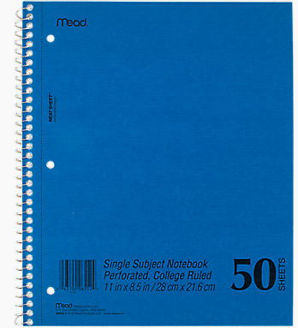
In the 6th grade course we will use notebooks to capture important vocabulary, diagrams, curious questions and observations. We will use our notebooks to prepare for assessments, complete homework and classwork assignments and engage in classroom discussions. Therefore, it is important that our notebooks:
- Remain neat and organized
- Are brought to every science class
- Are only used for science-related note taking (no doodling)
- Are legible!

After each unit, there will be a notebook check, which counts as a test grade. Students will be graded on the organization, neatness, and completion of their notebooks. If students are absent, they are responsible for acquiring missed notebook components and completing the missed class work outside of class time. Please see the following rubric for information regarding notebook expectations.

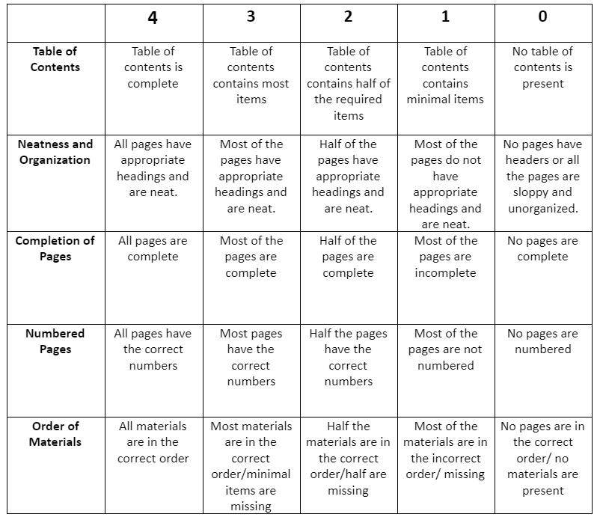
Contact Information
Ms. Moore
nmoore@excelacademy.org
Work: (617) 561-1371
Cell: (857) 256 0871 - Call or text anytime before 6 p.m.
Website: ncmoore.weebly.com

____________________________________________________________________________

6th grade Science is sure to be OUT OF THIS WORLD!

STUDENT  I have read and understand the course description and my expectations as a 6th grade science student.  Name:___________________________  Signature:______________________ | PARENT  I have read and understand the course description and my student’s expectations as a 6th grade science student.  Yo entiendo la descripcion de la clase y las expectativas de mi estudiante como un estudiante de ciencia del sexto grado.  Name:_____________________________  Signature:__________________________

